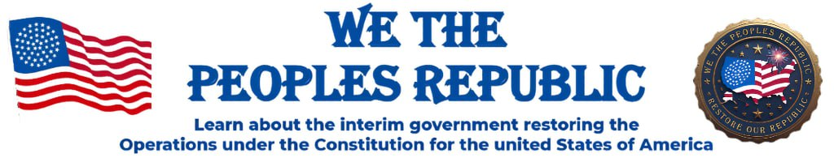
Newsletter
October 12, 2025

One Nation Under God

“Where patriots come to take back their country”.
(but we can’t TAKE BACK, until we’re willing to STAND UP)

www.wethepeoplesrepublic.org


Whether you are a new member or a long-time follower of our founder Tim Turner, please know you are in the right place, and we are honored you chose to be here…WELCOME!
This newsletter is for the people and by the people and our intent here is to be the voice of the people.
There are of course other platforms for communications like the website and our online Telegram channel (WeThePeoplesRepublic).
This Newsletter is but another way for you to stay informed and engaged in the process of “taking back our country”.
.
Newsletter Volunteers

Following is a list of ‘We the People’s Republic’ members who serve as volunteers to help make the newsletter a reality:
- Mike Schnaufer, editor and publisher / volunteer Mo.
- Janice Williams, contributing researcher & writer / volunteer Ok.
- Fred Pena, postmaster for webmail & webmaster of website / volunteer Ca.
- Stacy Pierce, manager for Telegram channel / volunteer Ia.
In addition, the following members volunteer to serve as Editorial Advisors:
- Debi Foli, interim Secretary of State California
- Christina Otto, volunteer, Pennsylvania Pioneers
- Marsha Strong, interim Governor Oklahoma

Results of Survey

In late August I surveyed the members of the Editorial Advisory Team and sent them their responses in early September. I wanted this ‘Reality Check’ to gauge how well we are doing, as these are the people closest to you, our readers given their respective roles and responsibilities.

Here are results of that survey:
- Where should our focus be?
Settling counties and educating our neighbors, church family, community in what a Constitutional Republic looks like.

- What do you want from WTPR national?
Educate the public, preserve our founding documents and a national leader

- Should the newsletter be national focused or tailored to each state,
and around what topics?
State focused and around Recruiting, Education, and Communicating Updates
.

Conclusions:
I originally thought the survey results would just be shared internally but recently I decided that maybe you, our readers, might appreciate knowing the preferences that some of your leaders expressed.
Our newsletter is still in its early development having started with its first issue on July 22nd, so we aren’t even 90 days into this yet. Nevertheless, we have continued to evolve in understanding what kind of content is needed or desired, and how written communications originate and get distributed.
As a result, since I’m pretty much a one-man band putting out the newsletter, there was no way for me to produce a state focused newsletter. The states have so much more available to them in the way of talent to draw upon from their members that it only seemed right that they take on the task of producing their own state-based newsletter. To this end I see Oklahoma has started to do so and I’m sure there are others doing something in the same regard.
With the states doing their own thing, I can stay focused on the bigger picture and what the Advisory Team advocated, that being recruiting, education and communicating updates. The updates can be from states that wish to share something with everyone, as well as national updates. In addition, since our newsletter goes out to all 15,000 members across the country, we want to make sure that all information driven by a national focus, be it events, training, committees, etc., that support the initiatives at the state and county level, get communicated to everyone.
As always, if anyone has any questions or suggestions, please send them to: newsletter@wethepeoplerepublic.org

I would really appreciate hearing from you!

What Would Charlie Do / Say?
(Authored and submitted by Mike Schnaufer, volunteer Missouri)

In the last issue of the newsletter I spoke of the tragic death of Charlie Kirk and the tremendous impact that his legacy is having on our world today.
Charlie’s life of courageous faith was an inspiration to all of us.
We The People’s Republic is a call to take back our country. We all joined because we believe in this higher calling and want to do our part.
But I surmised that this need not be the only thing we have in common, suggesting that we could also be known as a group united by forgiving one another and encouraging one another?
To my point, I would like to caution people on the words they speak. The Bible is clear that the tongue is powerful and is capable of speaking life and death. When we gossip about others or tear one another down, we are speaking death. So please, let’s choose LIFE.
When circumstances challenge or tempt us, and they will, we can ask ourselves:
‘What would Charlie do?’
And, when others say things that we don’t like or agree with, we can choose to bless or curse; stop and ask yourself:
‘What would Charlie say?’
Peter speaking to all Christians:
“Finally, all of you should be of one mind. Sympathize with each other. Love each other as brothers and sisters. Be tenderhearted and keep a humble attitude. Don’t repay evil for evil. Don’t retaliate with insults when people insult you. Instead, pay them back with a blessing. That is what God has called you to do, and he will grant you, his blessing.” ( 1 Peter 3:8,9)
Great Feedback from a Recent ‘Event’
(Submitted by Traci Motherwell)
A ‘Stay Awake America’ tour was held on Oct. 3rd and 4th in Dallas, Texas.
Our great patriots Stacy Pierce, Dave Roberts, Debbie Stephens and Traci Motherwell were all attending to help promote our We the People’s Republic. Dave was a guest speaker, and the team took turns helping to man a WTPR booth.
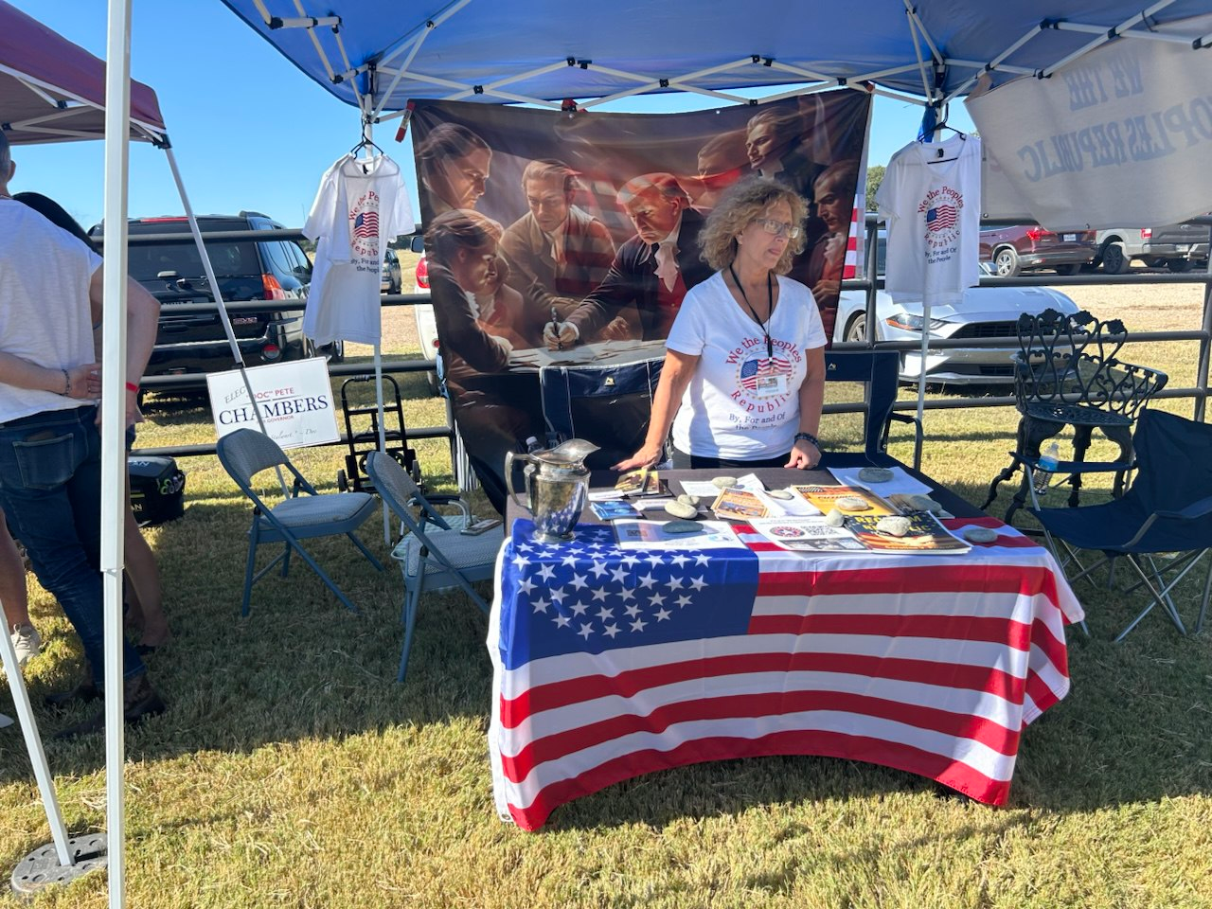

The group met people who still needed to be awakened and others who questioned who they were i.e. whether they were part of the former group. They were able to tell the story of We the People’s Republic and explain who we are, how we are not affiliated with the former group and that we still embrace the plan Tim Turner laid out and that was approved by the US Military. They recruited a total of nineteen (19) new members.

The Cesti Que Vie Trust
Understanding and Accessing Your Estate Funds;
A Dialogue Between Mentor and Apprentice
By Chairman of the Round Table
(Submitted by Caylan Cardano, volunteer Iowa)

Mentor: Welcome back apprentice, the Guild told me to expect your arrival so we have a great lesson prepared today. You’ve been told the system holds your value hostage—but what you haven’t been told is that your estate has already been created, funded, and bonded under your name. The trust exists. The question isn’t whether it’s real. The question is whether you know how to stand in it.
Apprentice: So the funds are already there?
Mentor: Precisely. The estate is established through a public construct the moment you’re born. The Cesti Que Vie Trust becomes the vessel that carries your estate through the commercial world. A Form 1099-A is not an application for aid—it is a lawful notice that the rightful owner has arrived to administer what’s his. You are not begging for permission. You are standing in position.
The Dual Role of Power

Mentor: There are two seats you must reclaim—Beneficiary and General Executor. These two together form your lawful standing.
As Beneficiary, you are the equitable heir—the one to whom the fruits of the estate belong.
As General Executor, you command the trustees to act—you give lawful instruction to the banks, the IRS, and every agency holding obligation to your estate.
Together, these roles restore both your right to receive and your power to direct.

The Origin of the Estate
Apprentice: Where does this estate come from?
Mentor: When you were born, the state created a bond in your name and placed it in trade. That bond—your commercial vessel—was monetized and registered through the Federal Reserve System. The red number on the back of your Social Security card reveals which Reserve Bank holds the account; the letter identifies the district.
Understand this, the bond represents your estate’s stored energy. The trust holds that energy. You, once awakened, administer it lawfully.

The Triad of Trust
Mentor: Every trust moves through three roles:
  - Beneficiary – The one who receives the benefit.
  - Executor – The one who gives lawful instruction.
  - Trustee – The one bound to perform the duties under instruction.
You, apprentice, must occupy the first two. The public—banks, IRS, courts—plays the third. Never invert that order. The moment you beg, you surrender standing.
Apprentice: So what is the 1099-A really doing?
Mentor: It’s a notice of action, not a request. It’s how you, the General Executor, instruct the trustee to perform settlement or discharge. You are not “asking for funds.” You are commanding performance on a pre-existing credit. The estate is already funded; your notice merely triggers release.
It’s not an application. It’s a declaration. It’s your lawful execution of duty.

Trust Law Governs All

Remember: Equity rules trust. The trustee cannot overrule the Beneficiary or the Executor. When your standing is clear and your paperwork is correct, their only lawful position is obedience.

Example of Proper Timing

Mentor: Picture the process.
Monday: You deliver your 1099-A package—cover letter, notices, and executor instructions—all signed under your authority.
Wednesday: The trustees perform—credits are executed, offsets occur, and the accounts reconcile.
The money was never “granted.” It was released. Your action compelled lawful performance.

The Final Lesson

Mentor: Apprentice, never forget—remedy is not a privilege. It is obligation once properly invoked. When you stand in full capacity—Beneficiary by birthright, Executor by authority—the trust must yield.

Apprentice: So my task is simply to stand correctly.

Mentor: Exactly. Stand as one who knows who he is, issues lawful instruction, and accepts nothing less than full performance. That’s the posture of a man reborn into his own estate.

Call to Action

Stand in your rightful roles. Speak with authority. Issue with precision.
For once the Beneficiary and Executor are united in one conscious being— the trustees must obey.

California Update
(Authored and submitted by Debi Foli, interim Sec. of State Ca.)
Our interim Governor Doug Hysell had a great talk with Tim Turner on Oct. 3, 2025. He went through all that we have done and all that we are planning to do. Tim is pleased and says it is all correct. Doug has guided us to stand our state up in accordance with the way Tim originally did it.
Next up… once we complete standing up all 27 counties, we will gather in Monterey to ratify all of the following documents.
- Declaration of Independence
- Articles of Confederation
- Treaty of Peace
- US Constitution 1789
- Bill of Rights
- California Constitution 1849

These documents give us the offices for which we will have our lawful elections.

I’d like to specify that we reseated our original seats of our Republic from our legislative sessions 1850-1853. We found commissioner, clerk, justice, court clerk and sheriff positions and reseated them at the county level.
Originally, Tim used Jural Societies to repopulate the state positions so we stayed with Tim’s original documents and are building the trifecta of our Jural Societies which include ecclesia, grand juries and militias. This lays the foundation for our common law courts.

Christians in Civil Government – Part 4
(Authored and submitted by Janice Williams, volunteer Oklahoma; as summarized from the book “The Role of Pastors & Christians in Civil Government”
By David Barton)

Part 4 of 5: Answering Objections

Objection 1: “Politics is dirty—Christians should stay out.”
- While politics can be messy, withdrawing only hands power to ungodly influences.
- Scripture shows that God often placed His people in positions of influence (Joseph, Daniel, Esther).
- Christians are called to bring truth, integrity, and light into every sphere, even politics.
Response: Avoiding civic life is not holiness—it is surrender.

Objection 2: “We should only preach the Gospel, not address politics.”
- The Gospel applies to all of life, including government and justice.
- John the Baptist confronted Herod’s immoral leadership (Luke 3:19–20).
- Pastors throughout history shaped law and policy through biblical preaching.
Response: Preaching the full Gospel means applying God’s truth to every area of life.

Objection 3: “Separation of church and state means Christians should be silent.”
- The phrase “separation of church and state” never appears in the Constitution.
- The Founders intended to prevent the government from controlling the church, not to silence the church.
- The First Amendment protects both free exercise of religion and freedom from a state-established church.
Response: Separation was meant to keep government out of the church—not Christians out of government.

✨

Closing Thought
When Christians step back from civic life, culture loses its moral compass. Addressing objections with biblical truth reminds us that God’s people are called to be courageous, not silent.

📌 Final Issue (Part 5): A Call to Action for Today’s Church

Committee’s Forming

On the Community Call of September 24th there was discussion and consensus on the primary goals to: (1) create more opportunities for members to be engaged, (2) draw in new members, and (3) bring greater awareness of the work of We the People’s Republic in building assemblies in their communities.
As a result, ideas were discussed regarding the formation of several new committees. Following are the stated purposes of each of those committees:
Committee for Church Outreach:
As followers of our Lord and Savior Jesus Christ, we are His foot soldiers called to be His salt and light. And for those of us chosen to be awakened to the fall of a Babylonian system / culture and the rise of the mighty move of God to come upon the earth, we have a responsibility to prepare our brothers and sisters in Christ for such a time as this.
Being a part of the We the People’s Republic (WTPR), we can be instrumental in reaching our local churches to educate and activate both clergy and church goers in how they were always meant to be active in civil government as well as the leading moral voice in their community.
We invite your participation in developing a strategy and the means to reach our local churches. If this is you, please contact the committee Chairperson, Janice Williams, volunteer Oklahoma, at:
elitephysiquebyjanice@gmail.com
-or-
405-766-0469

Committee for Assembly Outreach:

Being a part of the We the Peoples Republic, we can be instrumental in reaching out to our local communities to educate and assemble men and women to learn self-governance in how they were always meant to be active in local, state, and federal government as well as the body leading in their community.
We invite those of you who feel called to join in developing a strategy and the means to reach our local people.
In addition to the goals stated above:
- Recruit ambassadors in states

Committee for Website Development:

Being a part of the We the Peoples Republic, we can be instrumental in creating the face of our movement.
We invite those of you who feel called to join in developing a strategy and the means to reach our local people.
In addition to the goals stated above:
- Get members involved in assisting in website development
- Draw new members into the website
- Collecting data from states and counties

Committee for Communications:

Being a part of the We the Peoples Republic, we can be instrumental in creating the face of our movement.
We invite those of you who feel called to join in developing a strategy and the means to reach out to the people.
Our goal is to:
- Get members involved in topics to cover
- Outreach to podcasters and network within the circuit
- Build out social media presence
- Public Relations campaigns

Committee for Audio Series:

Being a part of the We the Peoples Republic, we can be instrumental in creating the face of our movement.
We invite those of you who feel called to join in developing a strategy and the means to reach out to the people.
Our goal is to:
- Get members involved in development of videos
- Historical audio series
- Vision audio series
- Who, What, When, Where, why audio series

NOTE: We will ask all committees to report back to the people on the weekly Community Call for public input.

Grand Juries
(Authored and submitted by Deborah Stephens, interim Governor Iowa)

We have become aware of Peacemaker Alto, who, after being jailed for 72 days, has dedicated himself to educating us on the significance of grand juries. He reminds us that, as a republic, it is our responsibility to take action and stand up for our rights. Peacemaker Alto also has President Trump's ear, which reinforces the importance of his message.
To truly make a difference, we need to form local assemblies and learn how to utilize grand juries. I encourage you to visit [website] for detailed information and to listen to the recording of our last assembly meeting, where Peacemaker Alto explains all the necessary steps. He also has a Facebook page for further insights.
The above is a new and different process to hold the courts accountable and does not replace the steps needed to still settle the counties. Many are confused, thinking that we are making a right turn on the steps and process when we are just adding more ways to help stop the courts from the abuse!
It is crucial that we achieve unity. The lack of unification among states, with each state doing its own thing, will ultimately lead to our downfall. While states can manage their own internal affairs, we must present a unified front at the national level. It is disheartening to see everyone starting their own little groups instead of coming together.
This effort is crucial, and it only requires a small group of dedicated individuals in each county. We cannot rely solely on our leaders or the military; we must take action ourselves.
If you are interested in joining this movement, please contact me at debbie@stevensautomotivesales.com or call me at 515-314-4948.

Events
We, the People's Republic, is preparing for our 2025–2026 National Tour of Celebration, which ends on July 4th at the Iowa World’s Fair.
We will provide more information in the coming days. Please check our Telegram Channel “We the Peoples Republic”; in the topic room “Republic State Events.” If you have any questions, please call or email Bev Kilmer. 850-933-6476; bFree@FreedomSpeaks.US .

Initiatives
Operating in Faith not Fear – overcoming setbacks with several counties in the process of establishing their Republican form of government in Oklahoma, Marsha Strong, interim Governor is using the same Oklahoma resolve to help other states in the Republic that may be inclined to avoid confrontation out of fear and to instead operate in faith when truth is on our side. You can reach Marsha at 580-206-5527

Governor’s call – Deborah Stephens, interim Governor Iowa and Lisa Puryear, volunteer, will be gathering monthly updates from each state as to whether they are settled on the land as yet and if not how many counties they have settled versus how many are needed; what’s working for them in recruiting new members; and, where they may need help with anything that we could get others to assist with.
Current Status:
24 states have at least one county settled
4 states have their required number of counties settled for the state to become de jure.

Open Meetings and Trainings

For members that reside in any state:
- Community Meetings on Telegram (see Community Video/ link folder at WeThePeoplesRepublic): Informational meetings with Q&A, every Wed. at 7pm CST. Recordings of mtgs. are subsequently available for those unable to attend.

- Training Meetings on Telegram (see Training Calls/link folder at WeThePeopleRepublic): Training sessions on assemblies and other constitutional issues, every Thurs. at 7pm CST. Recordings of mtgs. are subsequently available for those unable to attend.

- Q&A Meetings on Telegram ( see Tim’s Special Call folder at WeThePeoplsRepublic): An open invitation to ask any question or express any concern that you might have and hear what others have to say as well, every Sun. at 3pm CST. Recordings of mtgs. are subsequently available for those unable to attend.

For members in Pennsylvania: when members of the WTP Republic sign up at PennsylvaniaPioneers@protonmail.com you can join their assembly training calls via zoom on Wed. at 7:30pm EST (7pm for Ambassadors)

For members in California: for Californians that want to learn more about the California Republic and their Jural Societies, you can attend their bi-weekly Tues. meetings at Meetn.com/californiarepublicforthepeople, at 7pm PST.

A Strong Foundation
(Authored and submitted by Mike Schnaufer, volunteer Missouri)

Our founding fathers knew that in establishing a free and prosperous nation that it must be built on a strong foundation. I submit to you that there are two perspectives to bear in mind as you reflect on what constituted a strong foundation in creating these, the United States of America.
First and foremost, any new nation that aspires to bear a moral and religious founding needs the God of creation, His son Jesus the Savior of all mankind, and His Holy Spirit, at the helm. You see, while it was God who chose the Jewish people in creating their new nation, it was the Pilgrims who came over on the Mayflower who chose God in creating a new Christian nation. That is, our Forefathers made an ever-lasting covenant with God in founding America. This formed the basis on which ‘we the people’ were declared a free and sovereign people, who placed their trust in God. We MUST return to putting our trust in God.
Secondly, our founding fathers established a Republican form of government whereby the power and authority is at all times and in all ways in the hands of We the People. In the design of this government the Founders created 3 critical elements of self government that We the People were required to execute;
Assemblies, Common Law Grand Juries and Militias
Unfortunately, We the People stopped doing the work of self-governance and allowed the professional politicians and special interests to take charge. We MUST step up and re-claim our unalienable rights to self-government, that come from God.

Background
(Authored and submitted by Mike Schnaufer, volunteer Missouri)

The Republic for the united States of America is the actual true and lawful government that our founding fathers gave us. But in 1871 it was vacated when a corporation took over Washington D.C. and eventually every level of government in our country. In 2010, under the direction of our beloved and respected founding patriot Timothy Turner, the Republic was re-inhabited ( re-populated ).
Today, people around the country are busy re-seating the true Republic in every county of every state, in preparation for the dissolution of the corporation and, as President Trump has promised, a return of our country to the people.
To our members across the country, we ask that you encourage your family members and friends to be a part of this momentous period in our nation and join the We the People’s Republic (WTPR) by visiting our website at:
www.wethepeoplesrepublic.org
Our founding fathers created a republican form of government i.e. a Republic, built on the premise that we the people were the government and thus we the people would decide on the direction of the country and the policies that govern our actions, all consistent with our Declaration of Independence, Bill of Rights and Constitution. In other words, not a top-down government but one driven from the bottom up!!!
As well, our founding fathers looked to God our creator for divine direction and wisdom through regular corporate prayer, while putting their faith and trust in God Almighty.
“Our Constitution was made only for a moral and religious people. It is wholly inadequate to the government of any other.”
By John Adams, a Founding Father and 2nd USA President

Following in the footsteps of our founders, WTPR opens its gatherings and online meetings with prayer for wisdom and guidance.
Similarly, we develop policy at the grass roots level through various teams working on a variety of issues and endeavors all on behalf of WTPR.
In this stage of our development, we are focused on building a strong foundation consistent with our founding fathers vision of a Republic form of government that started with the people, i.e. at the county level of government.
To that end, we avoid the temptations of electing people to national office which, intentionally or not, eventually leads toward top-down directives and bureaucracy. Instead, we have state Governors providing support by filling key state and local county positions, training them in self-governance, and then empowering them to help members at the county level to establish a lawful republican form of government.
In this regard, we have experts in Constitutional law that bring a wealth of knowledge and understanding to our Republic and have helped shape two lawful paths for people to choose from in deciding how they at the county level wish to build their republican form of government. Your Governor may have a preference for one over the other, but it is still your choice. It is We the People who make the decision.
The Jural Assembly process, or path forward, is led by Dave Roberts who currently conducts weekly online training sessions. For more information you can reach Dave Roberts at 330-412-1919
The Jural Society process, or path forward, is led by California Republic interim Governor Doug Hysell. They have podcasts as well as recorded training sessions. For more information you can reach Debi Foli, interim Secretary of State at califss@proton.me or call Doug Hysell 209-289-1038.

Given some of the questions that people have posed, we are providing the following descriptions to help clarify the role of We The People’s Republic:
(Authored and submitted by Mike Schnaufer, volunteer Missouri)

What
A loose-knit, decentralized team of volunteers that function as a service organization to assist people wanting to form a lawful republic form of self-governance at the county level. The counties in turn elect people to serve as the interim state government. All being consistent with the lawful and internationally recognized documents for the Republic for the united States of America, as founded by Timothy Turner. (*)
How
Using a website, a Telegram channel, a newsletter, zoom calls, and onsite coordination of localized educational / promotional events, volunteers provide the tools, training and documents, that assist and support county assemblies, in conjunction with interim state officials, in their efforts to recruit, organize and establish their lawful county and state republic form of government.
Who
Members: We the People’s Republic (WTPR) is NOT a formal organization. Rather it is simply a name we use as members to identify ourselves as people aligned with a vision, mission and set of goals. (See below)
Volunteers: Members who become actively engaged as volunteers, can serve in any number of ways from being an interim office holder to assisting others in the process of establishing a county assembly.

(*) Please note that all county assembly settlement documents are between them in their respective states, and the Republic for the united States of America (the lawful government), and NOT with We the People’s Republic.

Vision: The United States of America, the land of the free, where ‘we the people’ are the government, taking responsibility to ensure all public servants are accountable to ‘we the people’ and who expect our public servants to fulfill their Oath to operate as a Constitutional Republic as established by our founding fathers in covenant with God Almighty.
Mission: To prepare people who love America, for their newfound civic responsibility within their communities, consistent with a republic form of government.
Goals: To actively pursue the following:
- To share with family, friends and neighbors, who are not yet awake, that we have an unlawful government running our country, and that we need to take it back.

- To invite those who are awake, to learn about our lawful republic form of government and become a part of their local assembly or to help start one.

- To participate in my own local assembly or start one if not yet established.

A CALL FOR:
Your news, progress reports, stories, events, questions, comments and suggestions

As stated in the Welcome, this is YOUR newsletter. So please submit your questions and comments, your success stories, the events you’re having, or invitations to join in a call or a special training that you are opening to anyone in the Republic. Remember to keep it positive and respectful. There is a strong desire out there to know how each other is doing and what’s working. Please send your submission to:
newsletter@wethepeoplesrepublic.org

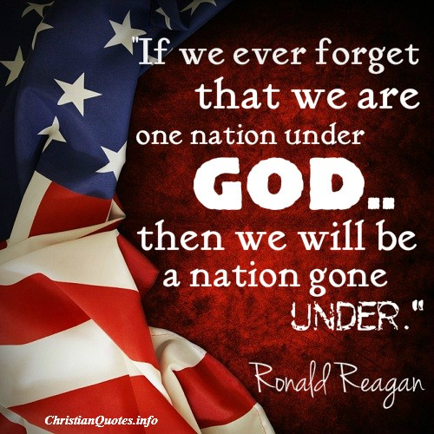
This Photo by Unknown Author is licensed under CC BY-SA

“But they who wait for the Lord shall renew their strength; they shall mount up with wings like eagles; they shall run and not be weary; they shall walk and not faint.” Isaiah 40:31

